Project Report Format

Final Phase

**1. INTRODUCTION**

1.1 Project Overview

This project uses **Tableau** to explore and visualize electricity consumption trends during **2019 and 2020**. The focus is on identifying how electricity usage patterns shifted before and during the COVID-19 pandemic, analyzing seasonal and monthly trends, and providing visual insights to support decision-making in energy management.

1.2 Purpose

**🎯 Objectives:**

* **Compare electricity usage** in 2019 (pre-pandemic) vs 2020 (pandemic year).
* **Identify peak and low usage months**, seasonal patterns.
* Visualize the **impact of lockdowns** or remote work on consumption.
* Create **interactive dashboards** for clear, dynamic data storytelling.
* Suggest **actionable insights** for improving energy efficiency.

**2. IDEATION PHASE**

2.1 Problem Statement

Electricity consumption is a critical metric for understanding energy demands, planning infrastructure, and driving sustainability efforts. However, usage patterns can fluctuate due to various factors such as seasonal changes, economic activities, and unexpected global events like the COVID-19 pandemic.

This project seeks to explore and compare electricity consumption patterns for the years **2019 and 2020** using **Tableau**, focusing on:

* Identifying key trends in energy usage across different months and seasons.
* Understanding the **impact of the COVID-19 lockdown** on electricity demand.
* Visualizing variations in consumption across regions or user types (residential, commercial, etc.).
* Providing interactive insights to aid **policy-making**, **energy planning**, and **user awareness**.

The goal is to use data visualization to uncover hidden insights, highlight behavioral shifts in energy use, and support more informed decisions in energy management for the future.

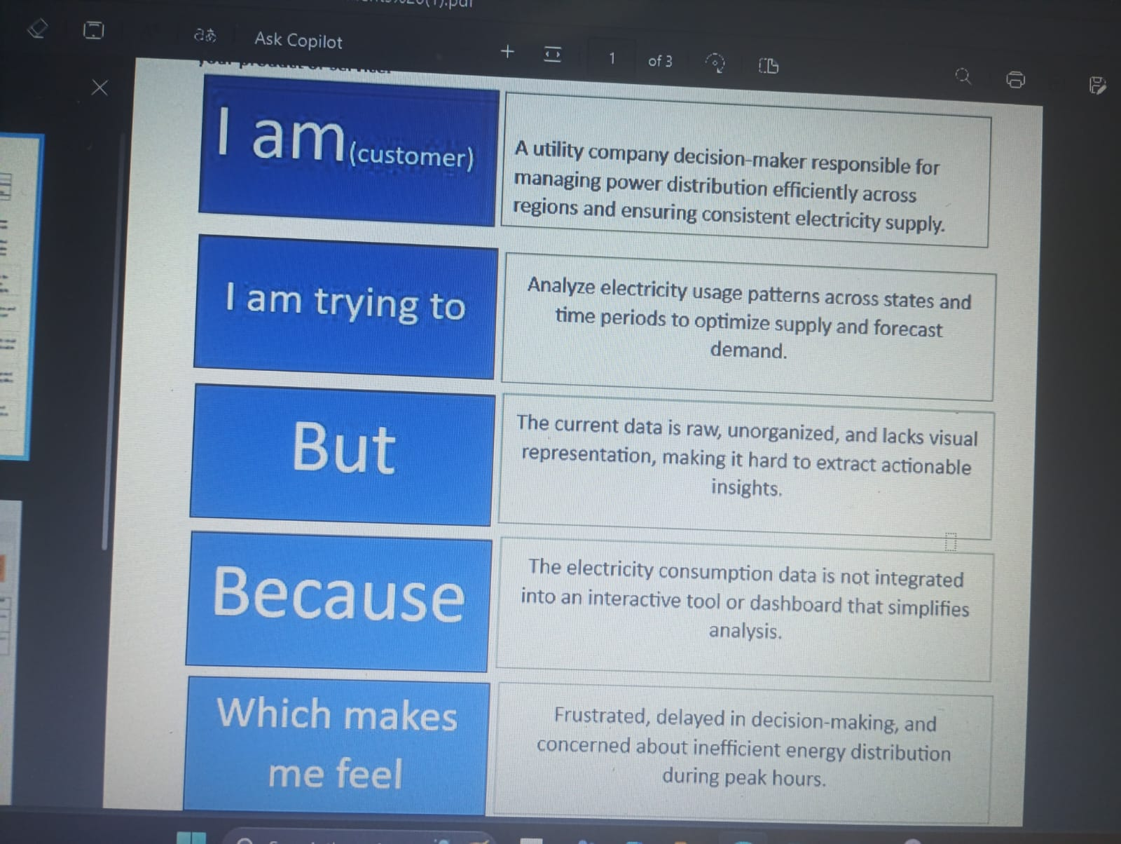

2.2 Empathy Map

EmpathyMap Canvas: An empathy map is a simple, easy-to-digest visual that captures knowledge about a user’s behaviours and attitudes. It is a useful tool to helps teams better understand their users. Creating an effective solution requires understanding the true problem and the person who is experiencing it. The exercise of creating the map helps participants consider things from the user’s perspective along with his or her goals and challenges.

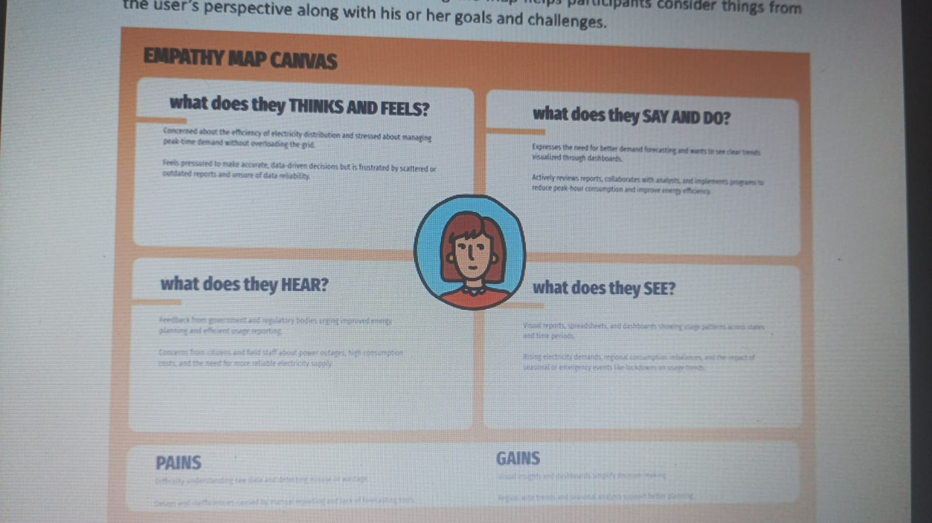

2.3 Brainstorming

Step-1: Team Gathering, Collaboration and Select the Problem Statement Our team came together to address a real-world issue with national importance. After discussing themes like sustainability, digital transformation, and development, we chose to focus on electricity consumption in India — a crucial area impacting the economy, environment, and public utilities. Weidentified challenges such as regional differences, seasonal demand changes, and the need for better energy planning. Recognizing the power of data visualization, especially using Tableau, we decided to analyze electricity usage patterns to gain actionable insights. Problem Statement: “How can electricity consumption patterns be visualized and analyzed to improve energy management, promote sustainable practices, and enable data-driven decision-making across different states and regions of India?”

**3. REQUIREMENT ANALYSIS**

3.1 Data Flow Diagram

**4. PROJECT DESIGN**

4.1 Problem Solution Fit

The Problem-Solution Fit simply means that you have found a problem with your customer and that the solution you have realized for it actually solves the customer’s problem. It helps entrepreneurs, marketers and corporate innovators identify behavioral patterns and recognize what would work and why Purpose:

❑ Solvecomplexproblemsinawaythatfits the state of your customers.

❑ Succeed faster and increase your solution adoption by tapping into existing mediums and channels of behavior.

❑ Sharpen your communication and marketing strategy with the right triggers and messaging.

❑ Increase touch-points with your company by finding the right problem-behavior fit and building trust by solving frequent annoyances, or urgent or costly problems.

❑ Understand the existing situation in order to improve it for your target group.

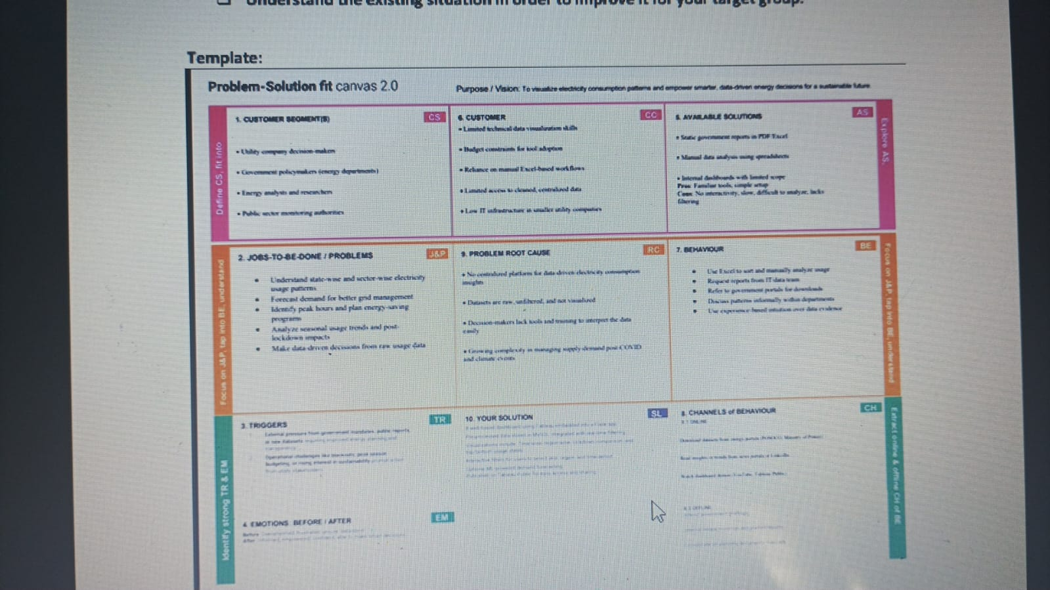

4.2 Proposed Solution

4.3 Solution Architecture

Solution architecture is a complex process– with many sub-processes– that bridges the gap between business problems and technology solutions. Its goals are to:

• Thearchitecture separates data preprocessing, storage, visualization, and UI layers—making it easy to maintain, scale, and enhance.

• Cleaned data from MySQL is visualized using Tableau dashboards, offering region-wise, year-wise, and seasonal insights with filtering capabilities. • Dashboards are embedded into a Flask-based web interface, allowing end users to interact with visual data through a user-friendly portal.

• Thesolution supports future extensions like forecasting models and can be deployed locally or on cloud platforms like Heroku or AWS.

**5. PROJECT PLANNING & SCHEDULING**

5.1 Project Planning

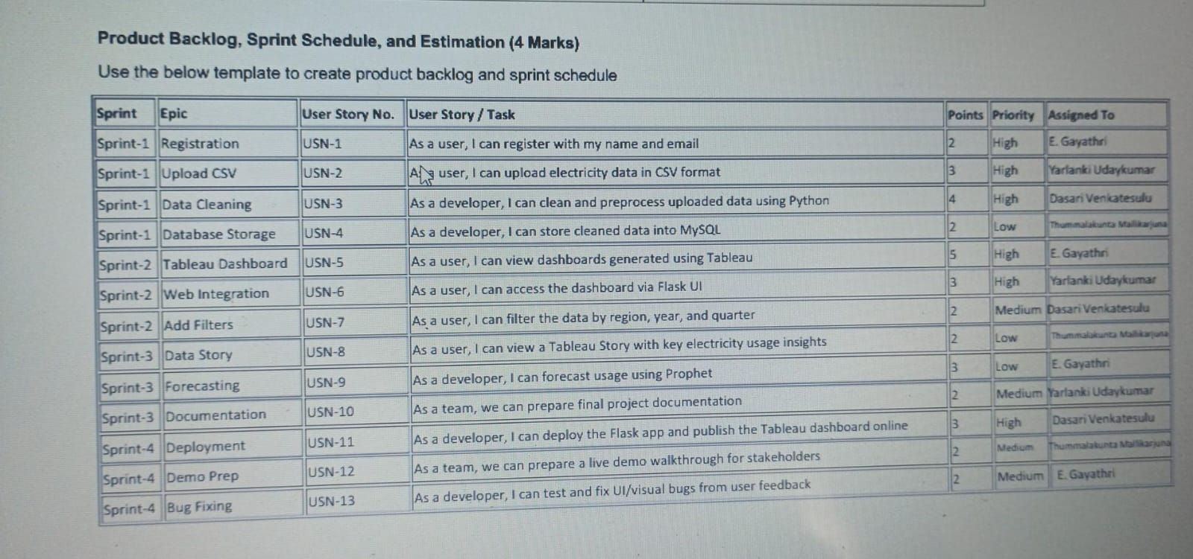

**6. FUNCTIONAL AND PERFORMANCE TESTING**

6.1 Performance Testing

**Model Performance Testing:**

Project team shall fill the following information in model performance testing template.

|  |  |  |
| --- | --- | --- |
| **S.No.** | **Parameter** | **Screenshot / Values** |
|  | Data Rendered | Electricity consumption data from states and regions of India from 2019–2020 in .csv. Columns used include Region, State, Date, MU, Month, Quarter, and Lockdown. |
|  | Data Preprocessing | Null values handled, new fields derived (Quarter, Month, Lockdown), filtered for required years. This was done using Python (Pandas) and stored in MySQL before importing into Tableau. |
| 3. | Utilization of Filters | Filters applied in dashboard:   * **Region** * **State** * **Year** * **Quarter** * **Lockdown (Yes/No)** Used across all dashboards to enhance interactivity. | | 4 | **Calculated Fields Used** | Created fields in Tableau: * Year(Date) * Month(Date) * Quarter(Date) * Lockdown Label for categorizing data before and after lockdown. * Top N States (for usage comparison). | | 5 | **Dashboard Design** | **Number of Visualizations:** 3 Dashboards Each dashboard includes: * Line Chart (Monthly trends) * Bar Chart (State-wise comparison) * Map / Tree Map (Region-wise consumption) * KPI indicators (Total and Average Usage) 📎 Refer: *Screenshots of Dashboard.pdf* | | 6 | **Story Design** | **Number of Slides/Graphs in Story:** 15 Covers: * Intro & Problem * State-wise Usage * Lockdown Comparison * Regional Patterns * Seasonal Trends * Insights + Conclusion |
| 4. | Calculation fields Used | | **Field Name** | **Formula (in Tableau)** | **Purpose** | | --- | --- | --- | | Year | YEAR([Date]) | To filter and group usage by year (2019, 2020) | | Month | DATENAME('month', [Date]) | For month-wise trend analysis | | Quarter | QUARTER([Date]) or DATENAME('quarter', [Date]) | To compare quarterly usage | | Lockdown Flag | IF [Date] < #2020-03-24# THEN 'Pre-Lockdown' ELSE 'Post-Lockdown' END | To analyze impact of COVID-19 lockdown | | Total Usage | SUM([MU]) | Calculate total electricity consumption | | Average Usage | AVG([MU]) | Show average usage per month/region | | Top States | INDEX() (used with sorting + filters) | To display top 5 and bottom 5 states | |
| 5. | Dashboard design | No of Visualizations / Graphs - 3 Dashboards , 8 Visualizations / Graphs.  A screenshot of a graph  AI-generated content may be incorrect.  A screenshot of a computer screen  AI-generated content may be incorrect.  A screenshot of a graph  AI-generated content may be incorrect. |
| 6 | Story Design | No of Visualizations / Graphs -12 slides.    A map of the world  AI-generated content may be incorrect.  A screenshot of a computer  AI-generated content may be incorrect.  A screenshot of a computer  AI-generated content may be incorrect.  A screenshot of a graph  AI-generated content may be incorrect.  A screenshot of a graph  AI-generated content may be incorrect.  A screenshot of a graph  AI-generated content may be incorrect.  A screenshot of a graph  AI-generated content may be incorrect.  A screenshot of a graph  AI-generated content may be incorrect.  A screenshot of a computer  AI-generated content may be incorrect.  A screenshot of a computer  AI-generated content may be incorrect.  A graph on a white background  AI-generated content may be incorrect. |

**7. RESULTS**

7.1 Output Screenshots

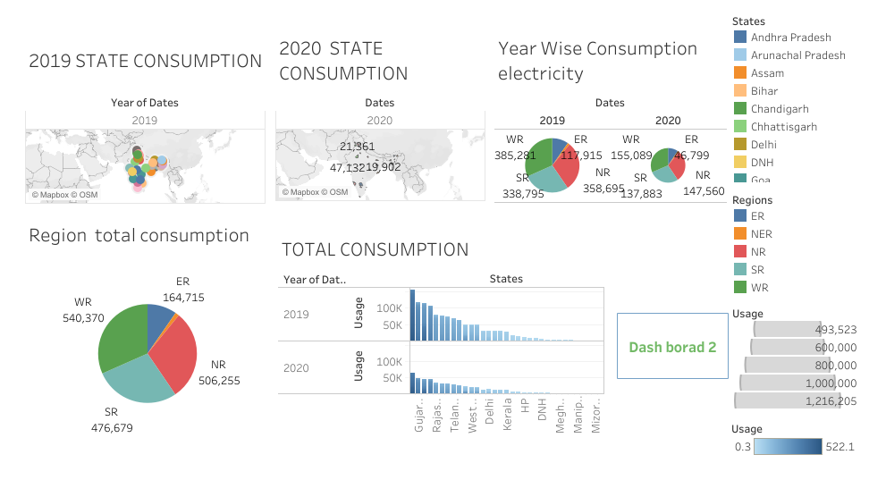

**8. ADVANTAGES & DISADVANTAGES**

Advantage: Optimizes resource allocation, reduces costs, enhances grid stability, and accelerates the transition to sustainable energy.

Disadvantages of Not Plugging into Future Electricity Consumption Patterns:

* Disadvantage: Leads to inefficiencies, higher costs, grid instability, and hinders environmental sustainability efforts.

9. CONCLUSION

The exploration of electricity consumption patterns in 2019 and 2020, particularly against the backdrop of the COVID-19 pandemic, vividly demonstrates the critical importance of "plugging into the future" through robust data analysis and forecasting.

In 2019, global electricity consumption was characterized by continued growth, albeit with a notable slowdown in developed economies and robust expansion in non-OECD countries, particularly India and China. This period also marked a significant shift towards low-carbon energy sources, with renewables and nuclear power collectively surpassing coal in global electricity supply for the first time.

The year 2020 served as an unprecedented stress test, with the COVID-19 pandemic causing a sharp and significant global decline in electricity demand, especially in industrial and commercial sectors. While residential consumption saw a slight increase due to work-from-home trends, it was largely overshadowed by the broader economic slowdown. This disruption also led to a higher penetration of renewables in the energy mix, as their output was less affected by demand fluctuations, pushing fossil fuel generation downwards.

For India, specifically, the period mirrored global trends to a significant extent. While 2019 saw continued growth in electricity demand, driven by industrialization and urbanization, 2020 experienced a substantial dip due to the nationwide lockdown, particularly impacting industrial and commercial demand. However, unlike some developed nations, India's underlying growth trajectory meant that the recovery in consumption was relatively swift as restrictions eased. Indeed, post-2020, India has continued to see a strong upward trend in electricity consumption, with significant capacity additions in renewable energy sources like solar and wind, alongside a continued reliance on coal to meet burgeoning demand.

The overarching conclusion of this project is clear: understanding and accurately predicting electricity consumption patterns is not merely an academic exercise but a fundamental necessity for efficient, sustainable, and resilient energy systems.

10. FUTURE SCOPE

11.Dataset Link : https://drive.google.com/file/d/1JxIkHNwXxjFztKq7ad0_KtkukCqTckNy/view?usp=sharing

GitHub & Project Demo Link: